Employee Salaries

Write a query that prints a list of employee names (i.e.: the name attribute) for employees in Employee having a salary greater than per month who have been employees for less than months. Sort your result by ascending employee_id.
Input Format
The Employee table containing employee data for a company is described as follows:
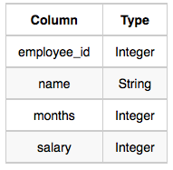
where employee_id is an employee's ID number, name is their name, months is the total number of months they've been working for the company, and salary is the their monthly salary.
Sample Input
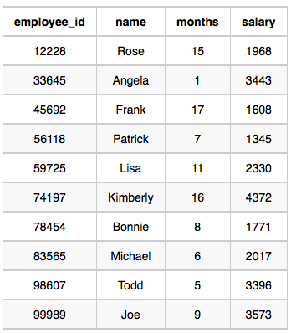
Sample Output
Angela
Michael
Todd
Joe
Explanation
Angela has been an employee for month and earns per month.
Michael has been an employee for months and earns per month.
Todd has been an employee for months and earns per month.
Joe has been an employee for months and earns per month.
We order our output by ascending employee_id.

